Title: Task Pies  
A short, creative, and marketable title capturing the key idea.

Our title and app name stems from a task prioritization strategy recommended by psychologists called task buckets or the bucket system. The bucket system is useful for those who are neurodivergent as it helps them break down large, daunting tasks into smaller, manageable tasks in categorized to-do lists. People who are neurodivergent can find it difficult to regulate and delegate energy, so the smaller lists or buckets allow them to manage tasks based on energy level which “cuts down the possibility that you’ll wile your prime energy time away” on small tasks (Caldwell and ADDept.org). We chose to use a pie chart to visualize task completion, hence Task Pies.

# Team Members:

Brandi Kuehn, Claire Pini, Thomas Rusch, Vi Conrad

Problem and Solution Overview: (2 paragraphs)  
A concise statement of the problem you are tackling, its importance, and a brief synopsis of your proposed solution.

The main issue that has led us to create a to-do list app for those who are neurodivergent is that many apps currently available are catered only to neurotypical people. The same productivity strategies that work for them do not work for those who are neurodivergent.

It’s easier to keep track of stuff online — and now you can easily share your thoughts and stay organized.This app lets you write down what you’re thinking about, and title the task so you can organize tasks into groups, like learning, personal or work. Once you create a task, it automatically goes to our task-management service, where it will appear on your homepage. You don't have to do anything and you'll get reminders of blog tasks due today or tomorrow - after today's due date has passed. Then when you click the link to a blank task page on TaskPies, all the information is pre-populated, including an automatically created due date. What will you task to?

We plan on making our app convenient and rewarding. Notifications need to be easy to create and organize, and we want the user to be able to mark notification tasks as complete with only a single tap. To make tasks rewarding, we will give the user points for every task they complete. These points can be spent to buy hats for their user icon! We will also create celebration animations that can play when a task is completed.

Supported Tasks: (1-2 pages)  
Describe the tasks that your users will be able to complete when the project is complete. Discuss how these tasks allow your user to solve the problem described above. If possible, include screenshots of how your project supports these tasks.

Once our app is complete, the user will be able to utilize it regularly to help them organize and complete their daily tasks. This app will cater to those who are neurodivergent, although it will have features that can be used by anyone to remember all the tasks they need to complete in a clear, concise, yet not overwhelming fashion.

As a task app, it is only natural that the main feature will be creating tasks with set completion dates. These tasks can be stored in separate categories to keep everything organized, so you can stay informed on how many tasks are learning, personal, or work-based. The user will be able to check off tasks throughout the day, keeping up to date and making sure a task isn’t completed twice. On top of this, if a user completes all of their tasks for the day, they receive XP points, which can be used to purchase hats to put on our mascot! To make sure a user can put a task in and remember to complete it by a certain day, the app will send notifications to the user, reminding them of what they need to do unobtrusively.

As previously mentioned, our app has a cute mascot that helps create a welcoming atmosphere in the app. They will greet you every time you open the app and will be displayed with the general split of where your work is on that day. Not only being a happy face, but our mascot is also there to allow you to use points to unlock cosmetics that you can add to it, personalizing them to your preference.

To make sure the app stays in style, the user can go to the settings page and change a lot of the visual and mental stimulation. The user can swap out the default colors for some brighter colors, or darker ones if that is more their style. There will also be options on how the notifications work if you feel that they would be too pesky during a certain time of the day, thus setting them during your calmer hours to avoid the stress from being overwhelmed by it, and to make sure they have time to complete it.

It is easy to learn where all these features can be found, as when you first download the app it will walk you through the tutorial, which will show you where you need to go in the app to use the app to its full potential. If the user ever forgets where the different features are, or just needs a review after an extended time of not using the app, the tutorial will be easily accessible in the settings area.

With the customizability of the app, easy set-up, and the amusing prizes the user can unlock, any user using this app will have a much harder time falling behind on their assignments or forgetting to take care of their personal needs.

This app is for those who have ADHD and need a way to organize and delegate tasks. The smiley face mascot helps you remember that your actions affect others, so do something nice to yourself. The app was designed with users of all ages and abilities in mind, so it can be used by millions of people across the world.

Technical Details: (1-2 pages)  
Discuss the technical details of your implementation. What tools, libraries, etc. are you using? How is your project broken up into components? Include citations to any tutorials/libraries that you are using.

For our design phase of this app, we originally sketched out designs using different drawing/sketching software. We then transferred the sketches into app mockup iterations using Adobe XD. Icons from the Google Material Design UI Kit were used in the mockup of this app.

We are creating this app as a PWA. However, we are embedding the PWA into a container so that we have better access to native device features, such as better notification support and geofencing.

For the PWA, we are using React and Ionic. These tools work well together to let us create a polished, yet very customizable, user interface. We are also researching more tools, like Tailwind CSS, Swiper JS, and Konsta UI.

To encapsulate our PWA, we will use Capacitor, Android Studio, and Apple XCode. Capacitor’s many plugins will let us use many of the features that are usually only available to native apps. Capacitor is also backwards compatible with Cordova plugins, so we will have even more possibilities. The default Capacitor plugin for notifications is pretty limited and requires a lot of work to set up on Android. Instead, we’re going to look into a Cordova plugin called cordova-plugin-local-notifications. It’s pretty old but it still has thousands of weekly NPM downloads, so it’s worth taking a look at.

We are going to create celebratory motion graphics that have a random chance of playing when the user checks off a task. We haven’t decided on the tools yet, but Blender and Illustrator are candidates.

<https://www.adobe.com/products/xd/features/ui-kits.html>

[Konsta UI & Ionic | Konsta UI React](https://konstaui.com/react/ionic)

[Swiper - The Most Modern Mobile Touch Slider (swiperjs.com)](https://swiperjs.com/)

[Create an Ionic React App: Framework and Documentation (ionicframework.com)](https://ionicframework.com/docs/react#installation)

[katzer/cordova-plugin-local-notifications: Cordova Local-Notification Plugin (github.com)](https://github.com/katzer/cordova-plugin-local-notifications)

Progress Report: (1-3 pages)  
Describe what is completed of your project and what your next steps are for completing the rest of the project  
Note: Your grade for this section includes the grade for the project itself

Halfway through the semester, we are at a good place to complete our project on time. We have a good idea of the layout of the app and the skeleton. Granted, the skeleton may need to be modified, but it is a base point.

We started by meeting up and brainstorming ideas, which are shown in the sketches. Some of these were quite outlandish and others were more true to our initial vision. We decided to make the app upbeat and encouraging, as dopamine deficiency is one of the leading causes of incomplete tasks (Doyle and Colley 2022).

We decided to create a PWA app. A PWA application that lets a user make a to-do list of tasks and then add a description. The description can include varying information such as the completed or due date, or the title of the task. It is designed to work with a new TaskPies service with data from the TaskPies database so you can see what kind of tasks your users are making and when they’re completing them.

Claire created a variety of sketches and mockups in Adobe XD to make sure that we have a good idea of what the app will look like, and we decided as a group what elements to finalize. For example, we didn’t like the drop shadow behind our pie chart, but the shadow behind the tasks themselves was good to differentiate it. Another thing we thought would be good to get a visual idea of would be light versus dark mode. Many apps have the option for the user to choose between these two modes, depending on their preference. As we thought that it would add some more user customization and allow them to adjust the app to their own liking, having a light and dark version seems like a good option to have.

To make sure the app was not too stagnant, we also decided to create a mascot for the app. At the current moment, we have settled on a simple smiley face, meant to give the user a more enjoyable User Interface, as without it we felt the app seemed a little empty. Our mascot’s face helped breathe more life into the app, creating a more welcoming appearance.

We have the base skeleton setup, which was created by following an online tutorial, which is linked in the GitHub ReadMe. We are also using a react PWA template and importing react circular progress bar.

From here, we know what we want to do and are on schedule with our original timeline. We are planning to add two features and finalize it before Thanksgiving break, but this is flexible as extenuating circumstances do occur.

One feature we really want to add is task notifications. These would be implemented with Capacitor. We are considering sending daily notifications that can be toggled on or off depending on user preference. These would be to remind the user of their tasks as object permanence and, by extension, task permanence is difficult for those who are neurodivergent.

We are still assessing how to create the task pie chart, and we may use react circular progress bar, but it might not allow us to section out the tasks as we want them to be.

We are still figuring out what specific features we want to implement and what is feasible to create by the deadline. We would like to have a working “store” for our hats, which would be prizes and incentives after completing a certain amount of tasks. The store page and settings page will have similar layouts, to allow for consistence between all pages and elements in the app.

### Initial sketches:

Figure : Initial app layout and brainstorm

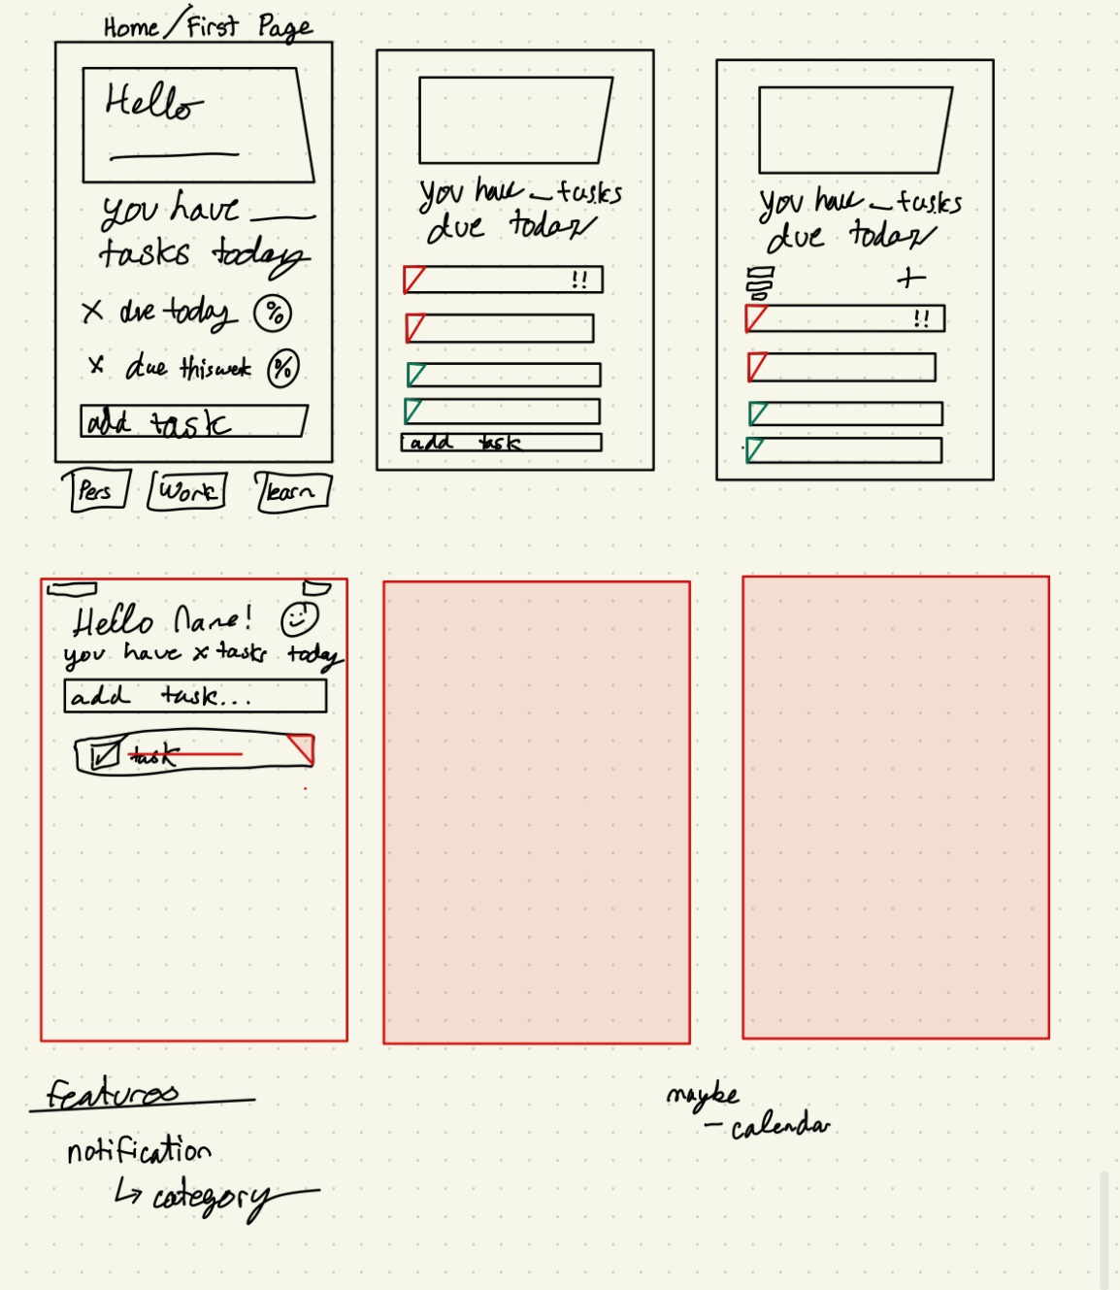

Figure : Adding a new reminder

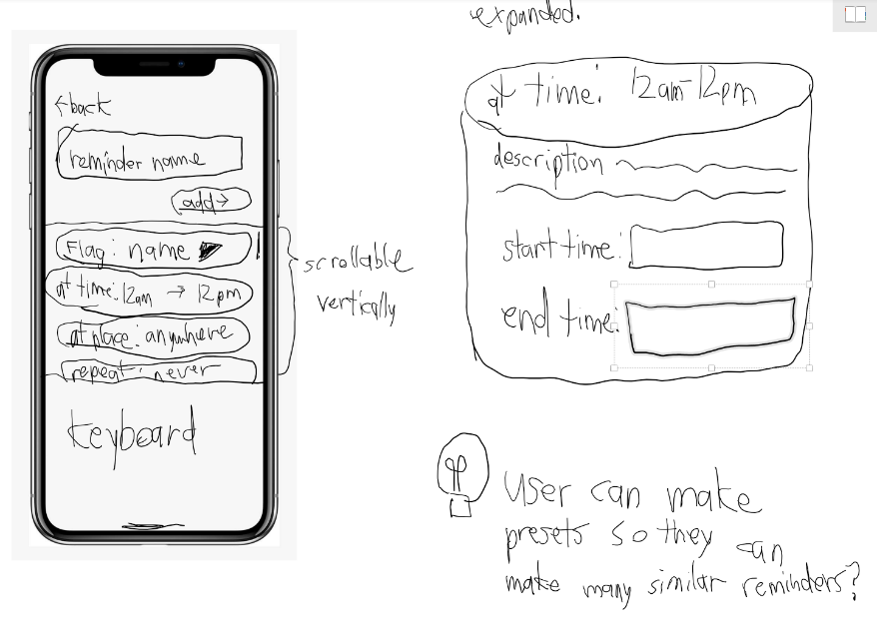

Figure : Reminder list concept:

Figure : Reminder list scroll down

Figure 5: Alternative idea instead of pie chart. (inspired by this web comic: https://iraprince.tumblr.com/post/631158826868031488/hey-im-kicking-off-the-adhdinvasion-hashtag-for)

*Figure 6: Below From Left to Right: Basic Main Page, Main Page w/text box (one task completed), task list w/sticky text box.*

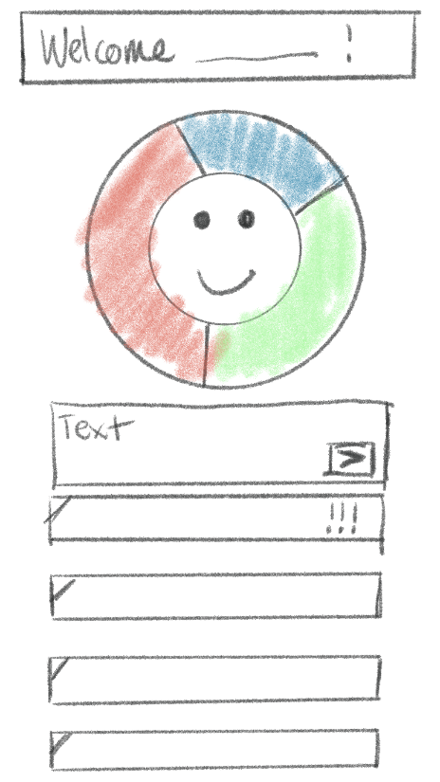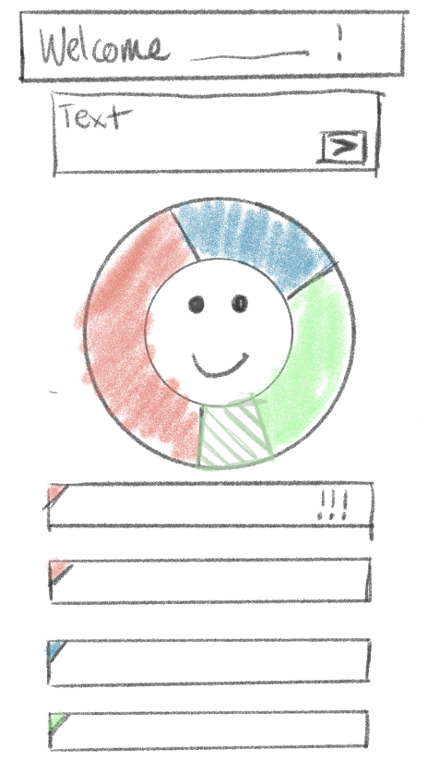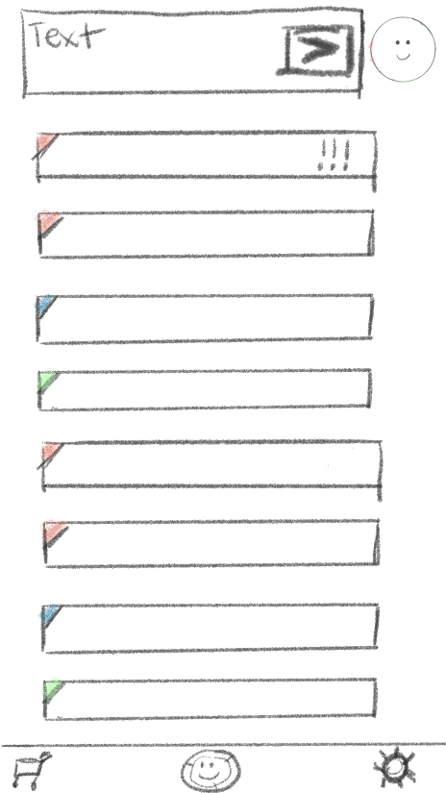

### Figure 7: Initial Hat Design 1:

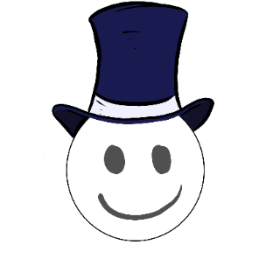

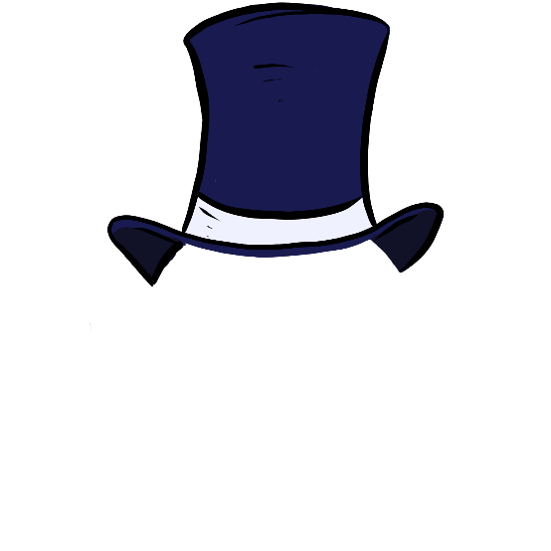

### Adobe XD Designs

*Figure 8: Below: Design option of lined elements vs lineless elements*

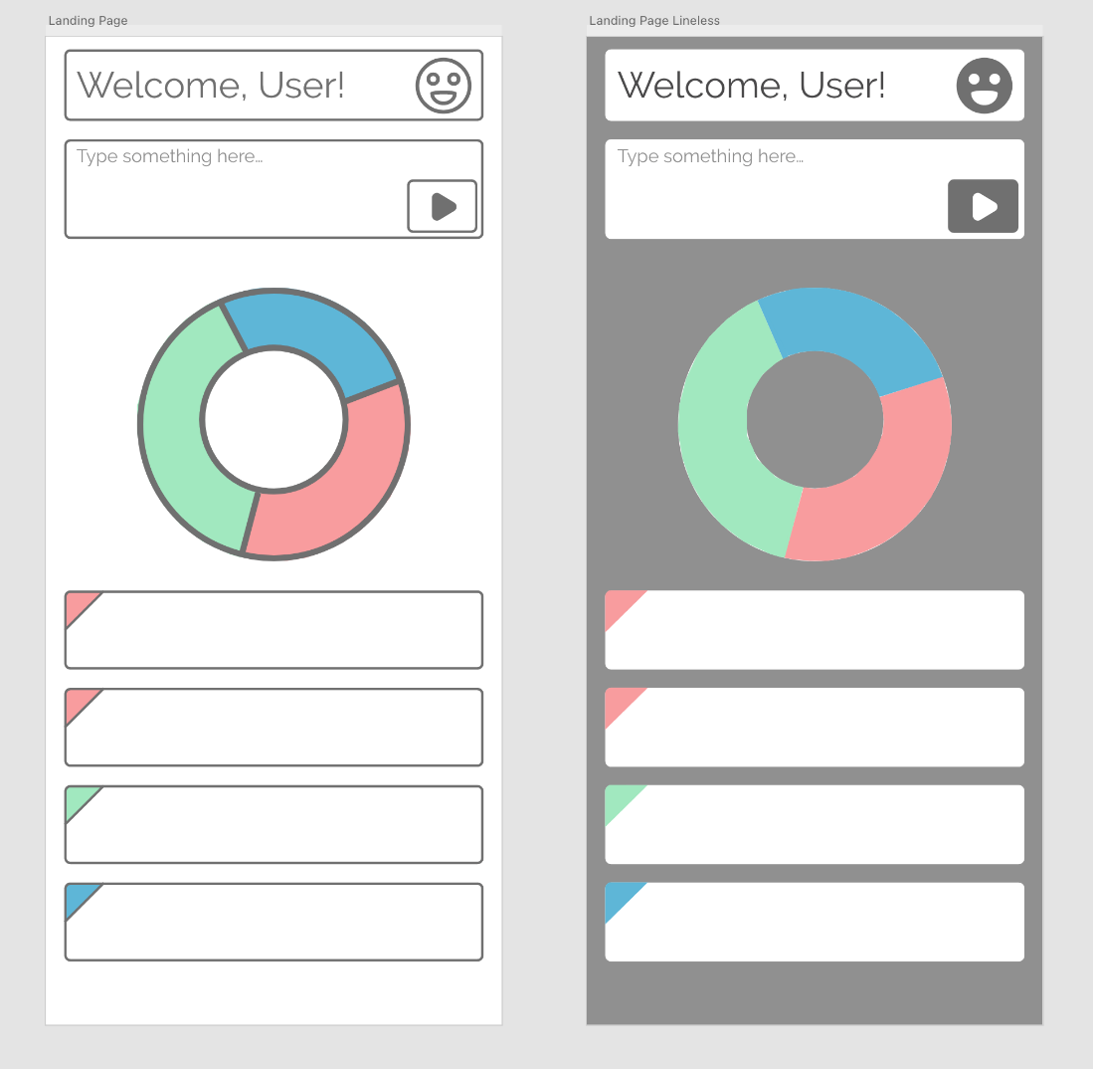

*Figure 9: Design option of drop shadow and minimal color. Introduces options for light and dark mode.*

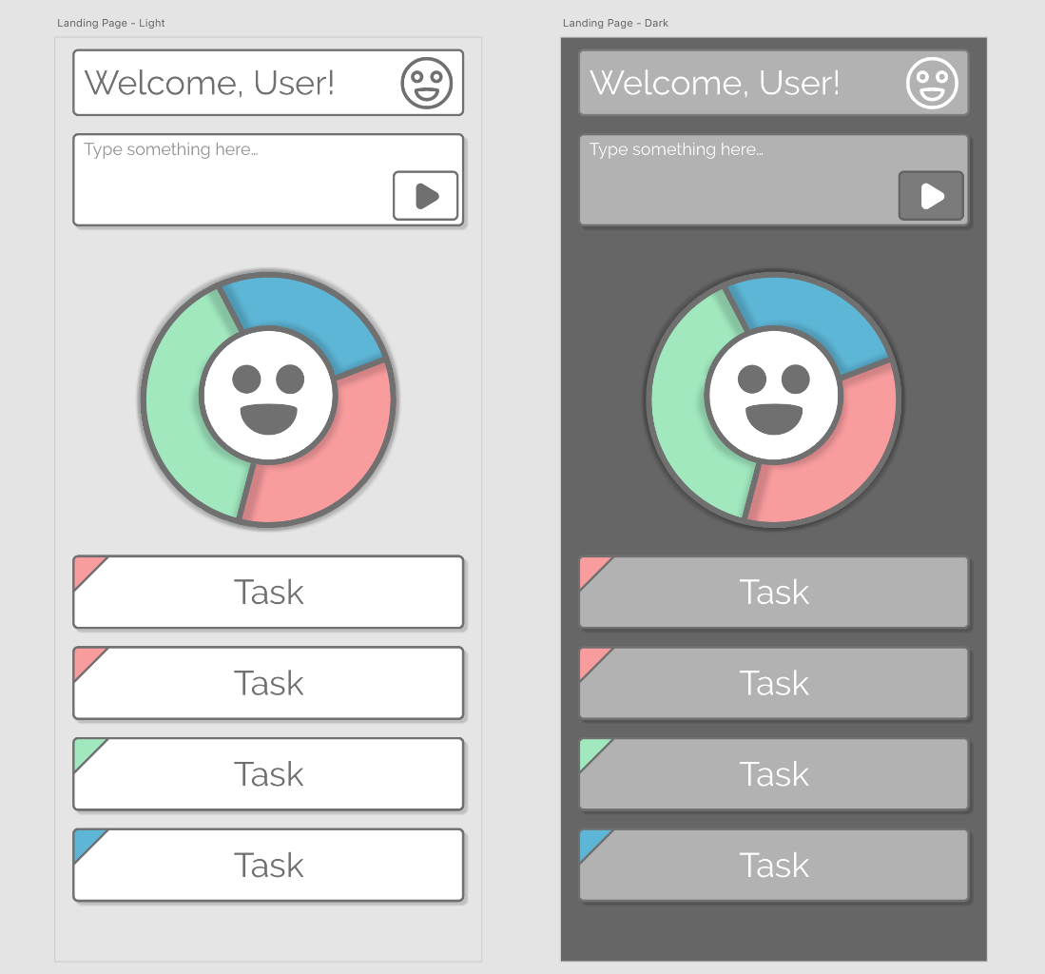

*Figure 10: Design option of colored lines and colored elements*

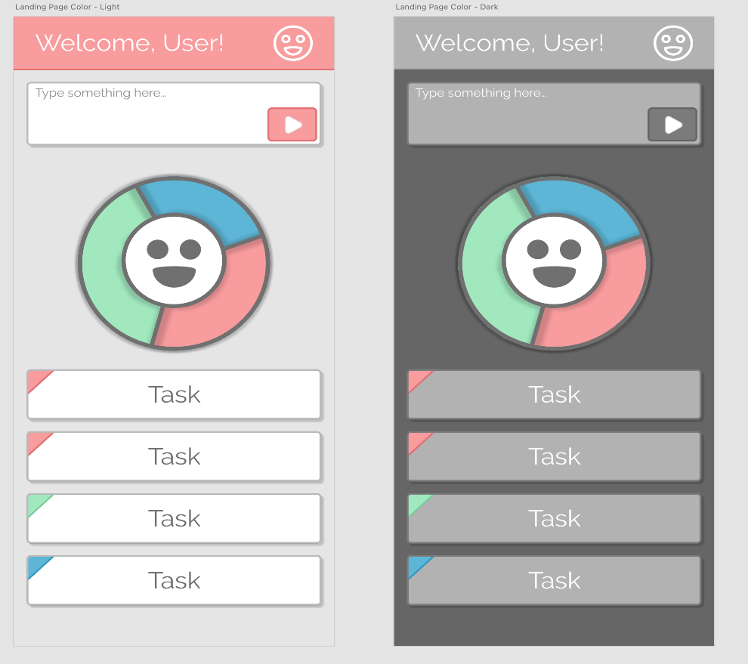

Current App Mockup

*Figure 11: From Left to Right: Landing Screen/Main Screen, Main Screen Scroll, Main Screen Task Pop Up*

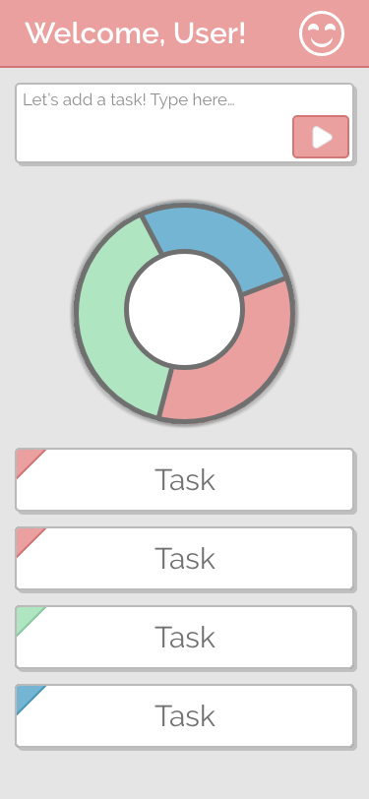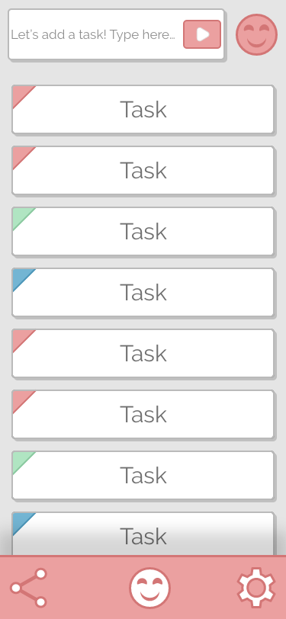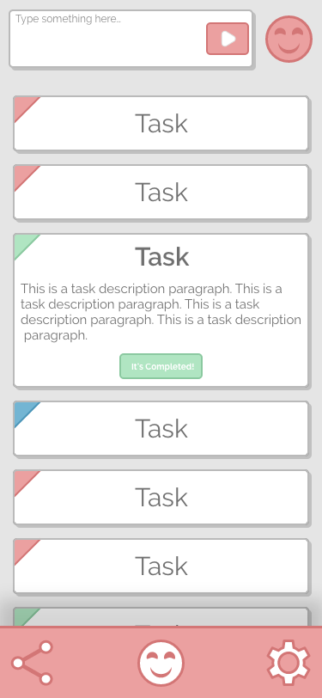

*Figure 12: From Left to Right: Extras Page (Hat Page), Settings Page, Settings Page Scroll*

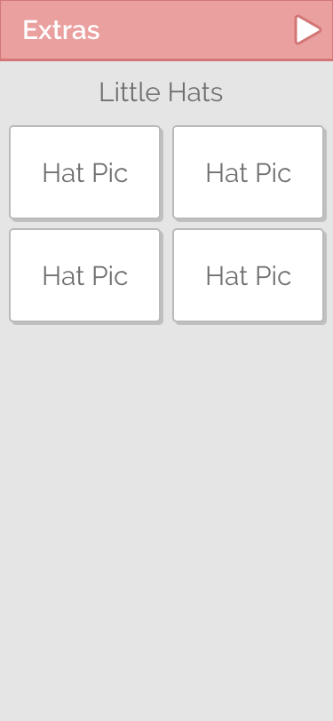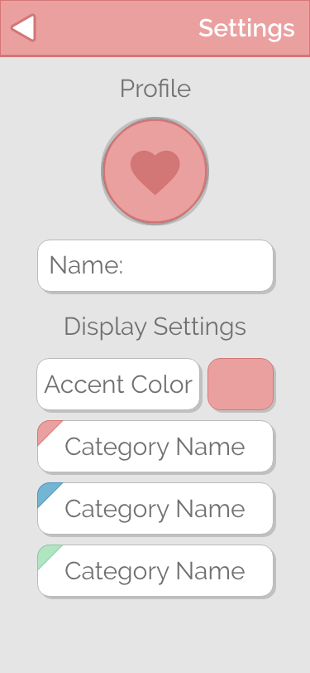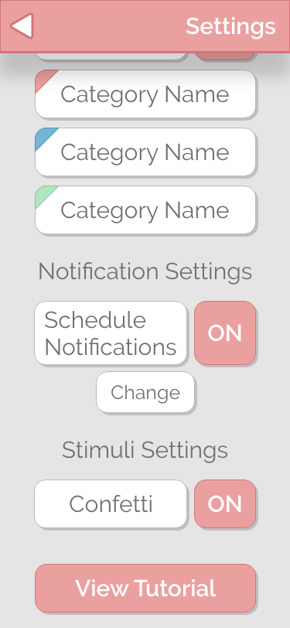

Challenges/Changes: (1 page)  
Describe any challenges you have encountered or changes that you have made since initially proposing the project.

Our original idea was to create a Google Chrome browser extension. It would detect what site the user was visiting in the active tab, and I would play the music that the user had associated with that site. An example could be playing music that helps with focus when the user studies Quizlet.

Unfortunately, this idea is no longer possible because of the new *Manifest v3* extension system. To improve security, Manifest v3 greatly restricts what browser extensions are allowed to do. New extensions cannot edit sites, so we cannot inject a music player. They also cannot access media on the user’s local device, so the user would not be able to upload their music.

The Manifest v3 system is already mandatory in all Chromium-based browsers, and it will soon be required in Firefox as well. We had to scrap this browser extension idea and create the idea we are moving forward with now.

We have more skill with web development than we do with native app development, so we wanted to create a PWA for our project. Unfortunately, PWA limitations create several challenges for us. Mainly, iOS devices do not allow PWAs to send notifications in the same way native apps can. This is a major problem because our app focuses on sending users notifications.

We have decided to use a PWA container that will let us have the best of both worlds. We researched React Native at first, but it wasn’t the right fit for our project.

One of the main problems that we are currently facing is making sure that the app is indeed helpful for those who are neurodivergent. Understanding how much stimulation is needed to keep people’s attention and interest while not overwhelming them is important and being able to keep everything simple and not easy to overthink.

So far, we have come up with a few ways to make this issue more obsolete. The first is by creating a tutorial that can point out all the features that are available to the user, so they can understand exactly how every button is used. We have also made sure that the original font coloration and style are simple and easy to read compared to bright colors. We are also working on exactly how our mascot will look, as our first run was less cute than intended.

Contribution (1-2 paragraphs)  
Include a paragraph describing each group member’s contribution to the report and presentation. Do not just state that you split the work equally - be specific. Did you divide the project by sections, by job, etc.

With the four of us combined, we have an extensive and diverse skill set which allows us each to specialize in different areas. We can work on separate tasks to reach completion at a faster rate, and we have met up once a week to check in and delegate new tasks.

Brandi Kuehn researched ADHD and how neurodiverse brains compare to neurotypical ones, to help find direction in starting the project, easy to understand language, and amount of stimulation to evoke dopamine to encourage more task completion. She is also creating the first hats that will be unlockable in the app.

Claire Pini used Adobe XD to design a mockup of the app and optimized UX with Brandi. She created numerous sketches and discussed them with the group before creating the mockup. She was able to create designs for both light and dark modes and will be contributing to hat creation. Additionally, she will be helping Thomas with CSS.

Thomas Rusch helped sketch a couple of initial designs for the app. He did the bulk of research into a Google Chrome Extension and later React Native, Ionic, and Capacitor. He has been vital in building a foundational understanding of React for the project and will contribute heavily to the CSS in the future.

Vi Conrad was the project manager and skeleton builder. She organized and delegated tasks to the group and helped make sure everyone was on track. She also helped create the initial skeleton of the app and its functionalities.

References  
List the references that you cite in the paper

n.d. React Native · Learn once, write anywhere. Accessed August 31, 2022. <https://reactnative.dev/>.

Caldwell, Marcy, and ADDept.org. “The Bucket System.” *ADDept.org*, https://www.addept.org/living-with-adult-add-adhd/the-best-to-do-list-for-adults-with-adhd. Accessed 4 October 2022.

Doyle, Nancy, and Mary Colley. 2022. “Neurodiversity - NCI.” DCEG. <https://dceg.cancer.gov/about/diversity-inclusion/inclusivity-minute/2022/neurodiversity>.

Hodges, Rick. n.d. “ADHD Webinar Materials.” Connecticut Parent Advocacy Center. <https://cpacinc.org/docs/ADHD-Webinar-Materials.pdf>.

“iOS 16 Preview - New Features.” n.d. Apple. Accessed August 31, 2022. <https://www.apple.com/ios/ios-16-preview/features/>.

Kircher-Morris, Emily. 2022. Raising Twice-Exceptional Children: A Handbook for Parents of Neurodivergent Gifted Kids. N.p.: Taylor & Francis.

Murphy, Kevin, Nancy Ratey, Sandy Maynard, Susan Sussman, and Sarah D. Wright. 2010. “<http://online.sagepub.com> Coaching for ADHD.” Journal of Attention Disorders 13, no. 5 (March): 546-552. 1087054709344186.

“react-native-notifications.” 2022. npm. <https://www.npmjs.com/package/react-native-notifications>.